

##### Question/Answer Booklet

Name: MEMO

PHYSICAL EDUCATION STUDIES

Yr 11 ATAR 2020

**Semester 1: Class Test 1**

**Time allowed for this paper**

Working time for paper: 45 minutes

**Material required/recommended for this paper**

*To be provided by the supervisor*

This Question/Answer Booklet

|  |  |  |  |
| --- | --- | --- | --- |
| **Contents:**  Developing Physical  Skills and Strategies  Motor Learning and  Coaching | 16 Questions | **Total marks** | **/55** |

**Multiple Choice (8 marks)**

1. A learner in the cognitive stage of learning would best benefit from feedback that is

(a) extrinsic, immediate and specific.

(b) intrinsic, immediate and specific.

(c) extrinsic, delayed and general.

(d) intrinsic, delayed and general.

2. A junior athlete who is taking part in her first surfing lesson, will benefit from

(a) verbal cues that are short and specific, such as ‘stay low’, as well as visual cues such as a demonstration.

(b) verbal cues that are technical and specific, such as ‘lower your centre of gravity to remain balanced’ as well as visual cues such as a demonstration.

(c) visual cues that are short and specific, such as ‘Stay low’, however, visual cues are not as beneficial.

(d) visual cues, such as a demonstration, however, verbal cues are not as beneficial.

3. A netball player practising her shooting skills, watches the ball as it travels through the ring. She is relying on

(a) extrinsic, terminal feedback.

(b) extrinsic, non-verbal feedback.

(c) extrinsic, augmented feedback.

(d) intrinsic (inherent) feedback.

4. Peta is coaching a younger athlete in high jump. As the athlete successfully lands on the mat and clears the landing area for the next jumper, Peta says, “Well done, you lead with your arm and pushed your hips towards the sky. Let’s move the bar up 2 centimetres and see if you can do it again.” Peta’s comment is an example of

(a) verbal, concurrent feedback to motivate.

(b) verbal, terminal feedback to reinforce.

(c) intrinsic, concurrent feedback to motivate and reinforce.

(d) verbal, terminal feedback to motivate and reinforce.

5. Diving is generally considered a closed skill because

(a) diving is performed indoors so the environment is closed.

(b) divers are not impacted by the wind or weather even if they perform outside.

(c) diving involves a predetermined routine with few changes in variables that can impact the performance of the skill.

(d) diving is a skill with a clear start and finish point so the skill it not open ended.

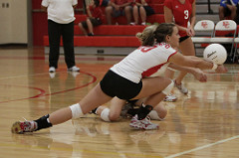6. In receiving a serve over the net, Phillipa decides to dig and moves accordingly. With reference to the Information Processing Model, this action is known as:

(a) Input.

(b) Output.

(c) Stimulus.

(d) Decision making.

7. Which of the following skills can be classified as the most discrete skill?

(a) 110m hurdles.

(b) Swimming 100m.

(c) Basketball free throw.

(d) Basketball lay-up.

8. Knowledge of results is an example of:

(a) Inherent feedback.

(b) Concurrent feedback.

(c) Extrinsic feedback.

(d) Intrinsic feedback.

**Short Answer (29 marks)**

**Question 9 (13 marks)**

The oceans of Australia’s west coast are home to some of the best surfing spots in the world. For this reason, surfing is a popular sport and recreational activity in Western Australia. Surfing begins with a surfer lying on their board and paddling onto a wave. Once they have caught the wave, the surfer then pushes up into a standing position and uses the movement and positioning of their main body and limbs to steer the board and ride the wave.

Classify **ocean surfing** according to the following criteria**.**

i) Write the motor skills for each classification system, ii) place a cross on the continuum and iii) justify your response for each.

(a) Muscle involvement (2 marks)

X

Fine Gross

|  |  |
| --- | --- |
| Description | Marks |
| Identifies surfing as being more gross than fine  Justification:  Surfing involves the use of the whole body, including the larger muscles of the legs (or similar) | 1 mark  1 mark |

(b) Environment (2 marks)

X

Closed Open

|  |  |
| --- | --- |
| Description | Marks |
| Identifies surfing as being at the higher end of an open environment  Justification:  Surfing takes place in the ocean which can be a highly varied environment, weather conditions must be considered, each wave is different. | 1 mark  1 mark |

(c) Continuity (2 marks)

X

Discrete Serial Continuous

|  |  |
| --- | --- |
| Description | Marks |
| Identifies surfing as being serial or slightly continuous  Justification:  Surfing involves a series of movements (paddling, pushing up, standing), once on the wave however, the surfer can continue riding until they fall off. | 1 mark  1 mark |

**Question 10 (4 marks)**

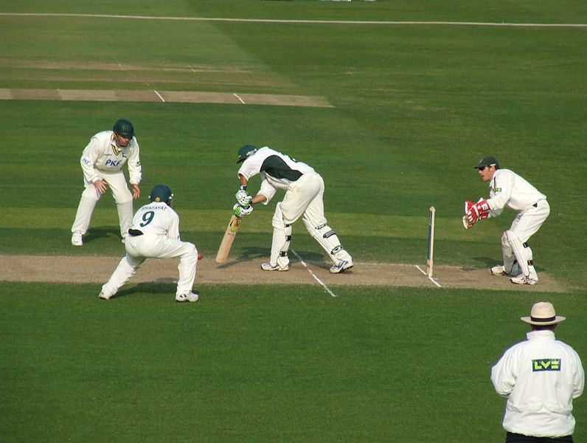The image below shows two fielding players standing in the positions of ‘silly point’ and ‘short leg’. They stand very close to the batsman, on either side of the pitch. These players must have a very good reaction time in order to attempt to catch the ball straight off the opposition’s bat. Describe the four phases of the information processing the fielders will go through as the ball leaves the opposition’s bat.

3. Response / Output

½ MARK

The selected movement response is executed

½ MARK

2. Response identification / Decision making ½ MARK

Athlete’s brain processes data for interpretation and formulates an appropriate response/movement

½ MARK

4. Feedback

½ MARK

Performance is evaluated from self, coach or other observer

½ MARK

1. Input/identification of stimulus

½ MARK

Athlete identifies the ball and other relevant cues ½ MARK

**Question 11 (2 marks)**

The NSW Swifts are versing the West Coast Fever netball team. The Swifts are 2 goals up with 30 seconds left to play. The Wing defence of the Swifts team intercepted the ball from the Fever team in the centre third of the court. Name 2 fundamentals that relate to strategies that they could use to win the game in the above scenario?

Deny space

Use space or

Control the pace

**Question 12 (2 marks)**

Jason Day practises his golf swing by hitting the ball into a driving net, similar to the one in the image below. Describe the type of feedback that Day relies on when practising this way.

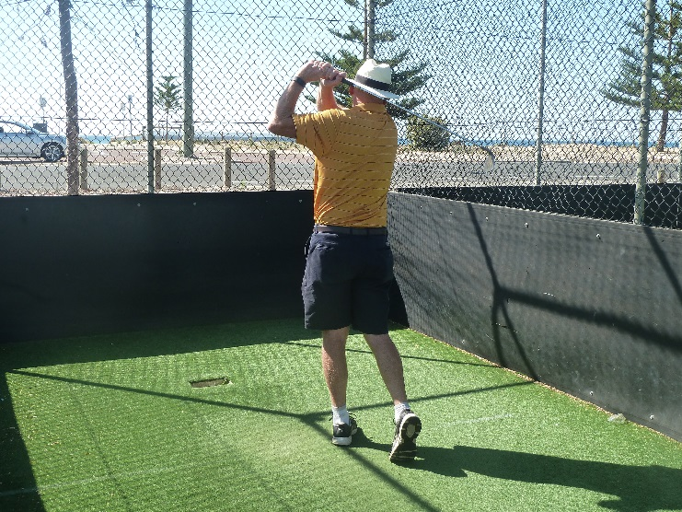

|  |  |
| --- | --- |
| Description | Marks |
| Identifies intrinsic (inherent) feedback  Day is relying on information on how the movement kinesthetically felt. | 1 mark  1 mark |

**Question 13 (6 marks)**

Games can be classified into variety of categories. From column A, provide the correct categories for the various games listed. Choose the correct classification from the choices listed here and write them opposite the game in column B.

Direct interceptive, Indirect interceptive, Performance Activities, Aesthetic Activities.

|  |  |
| --- | --- |
| A | B |
| Touch Rugby | DI |
| Netball | DI |
| Gymnastics | A |
| Cricket | II |
| Badminton | II |
| Swimming | P |

**Question 14 (2 marks)**

The West Coast Fever (WA netball team) coach, Stacy Rosman needs to refine her players’ skills for the grand finale. Name two types of analysis that she can use and one method for each analysis.

**Technique : Observation, Video recording, Biomechanical analysis**

**and Game analysis: Observation, Video and computer analysis, Statistics**

**Extended Answer (18 marks)**

**Question 15 (10 marks)**

1. The coach of an under 15’s basketball team has been focussing his training sessions on basketball shooting skills. In order to develop a suitable training program, he carried out a shooting assessment to observe the players’ current skill level. The coach gave each player two minutes to make as many successful shots as possible. Players were continually fed a ball to make the assessment more controlled. The results of three players are below.

|  |  |  |  |
| --- | --- | --- | --- |
|  | **Successful Attempts** | **Unsuccessful Attempts** | **Total Attempted** |
| **Player 1** | **25** | **4** | **29** |
| **Player 2** | **14** | **4** | **18** |
| **Player 3** | **6** | **12** | **18** |

According to the Fitts and Posner Model, identify which stage of learning each player would be classified into. Justify your response. (6 marks)

|  |  |
| --- | --- |
| Description | Marks |
| Player 1: Autonomous  Justification: Few errors were made (only 4 shots missed out of 29 attempted shows that he has a high degree of accuracy) | 1 mark  1 mark |
| Player 2: Associative  Justification: Few errors were made however however he only shot 18 balls which shows he was performing the action slowly (less fluent/ higher degree of concentration needed) | 1 mark  1 mark |
| Player 3: Cognitive  Justification: High number of errors | 1 mark  1 mark |

1. Identify **two (2)** types of cues you can use with relevant examples to assist Player 3 in moving to the next phase of learning. (4 marks)

|  |  |
| --- | --- |
| 1 mark for explanation of cue (max. 2)  1 mark for relevant example (max. 2) | **Cues**  *Any two of the following:*  Visual cues   * Visual demonstration of what is required and performance result * Example – visual image/model of ideal serve technique or other relevant example   Verbal cues   * Auditory explanation/feedback that is usually delivered in conjunction with visual cues. * Example – providing cue words such as “watch the ball”   Proprioceptive cues   * Experiencing the correct feeling of a successful performance * Example - physically placing body part in correct position. |

**Question 16: (8 marks)**

Anthony is a personal trainer who runs fitness sessions for athlete’s hoping to improve their running ability. He is currently training two athletes, Justine and Ruth. Justine is 20 years old and is new to the sport of long distance running. She is training to compete in her first half-marathon (21 kilometre event) at this year’s City to Surf. Justine hopes to finish in the top 10 for her age category. Ruth is 60 years old and has competed in a number of Ironman races over the past 20 years. After injuring her knee, Ruth, has had a break from training for the past two years. She has entered this year’s 12 kilometre event in the City to Surf. However, she is simply hoping to complete the race and is not aiming to be competitive.

Although Justine and Ruth are training for the same event, Anthony will need to develop individual training programs for each athlete. Identify and explain the **four** main factors that Anthony will need to consider when coaching Justine and Ruth.

|  |  |
| --- | --- |
| Description | Marks |
| Identifies: Age  As Ruth is significantly older than Justine, he will need to consider that she may have:  reduced cardiovascular ability,  reduced flexibility,  more brittle bones  reduced strength and power etc. (any one example is sufficient)  Or  Age can impact factors such as motivation, concentration arousal etc.  (or other relevant explanation) | 1 mark  1 mark |
| Identifies: Skill and/or fitness level  Ruth has greater running experience so her existing knowledge will likely be relatively higher  Or,  Ruth has been previously training for ironman events so her base level of fitness is likely to be relatively higher  (or other relevant explanation) | 1 mark  1 mark |
| Identifies: Injury  Ruth has recently had a knee injury so he should monitor this to avoid further injury (or similar response) | 1 mark  1 mark |
| Identifies: Level of competition/motivation  Justine is training to be competitive where as Ruth is training to participate. He should adjust his coaching style to suit. His style might be more casual with Ruth.  (or other relevant explanation) | 1 mark  1 mark |
| Identifies: Type of activity  Both athletes are training for a running event however Justine is training for a longer distance event. Her training load will need to increase to a higher level than Ruth  (or other relevant explanation) | 1 mark  1 mark |